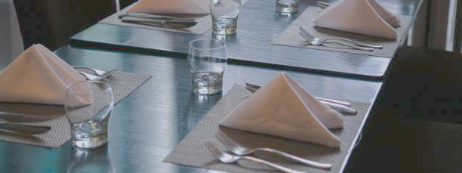

**Food Way’s**

BEST FAST FOOD RESTAURANT

‘’Our Restaurant Group is all about a more satisfying restaurant experience - on every level. Here you are truly our guest, and taken care of at every moment. In every last one of our locations, in all their variety, that feeling is there’’

**Food Way’s Restaurant**

‘’Exquisitely fresh and perfectly prepared, our menu reflects the love we have for all the best foods from all the best places.’’

**EVENTS AND PRIVATE DINING**

Whether you are looking for a private dining room, lounge space or a cocktail reception area, Food way’s Restaurant is an excellent choice for your special occasion – comfortably holding anywhere from 10 to 260 guests.

BOOKING POLICY

Set menus for groups over 12 guests. 50% deposit required. Guarantee number of guests due 72 hours before event. 18% gratuity applicable

M A X I M U M S E A T I N G CAPACITY-250gurst

P R I V A T E ROOM-60 guest

Whether you are looking for a private dining room, lounge space or a cocktail reception area, Food way’s Restaurant is an excellent choice for your special occasion – comfortably holding anywhere from 10 to 260 guests.

**EVENTS AND PRIVATE DINING**

**Food Way’s MENU**

**Food Way’s MENU**

**About Food Way’s**

‘’Exquisitely fresh and perfectly prepared, our menu reflects the love we have for all the best foods from all the best places.’’